LotLink
Smart Lot

University of Houston
CIS 4374

Iris Le Breton
CIS 4374
Prof. Dobretsberger

Semester Project

Week 1:
What already exists: I think we’ve all seen those green and red lights above parking spaces at least once in our lives, whether it was at the airport or the shopping mall. As innovative as that idea is, it isn’t always exactly accurate. Real-time data accuracy is the biggest flaw when it comes to smart lots, which is why we will be doing things differently. Figures 1 & 2 below show a bit of what already exists:
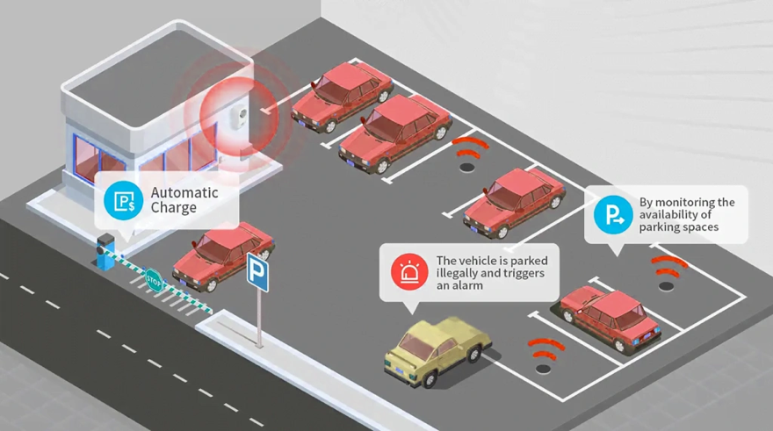

Figure 1

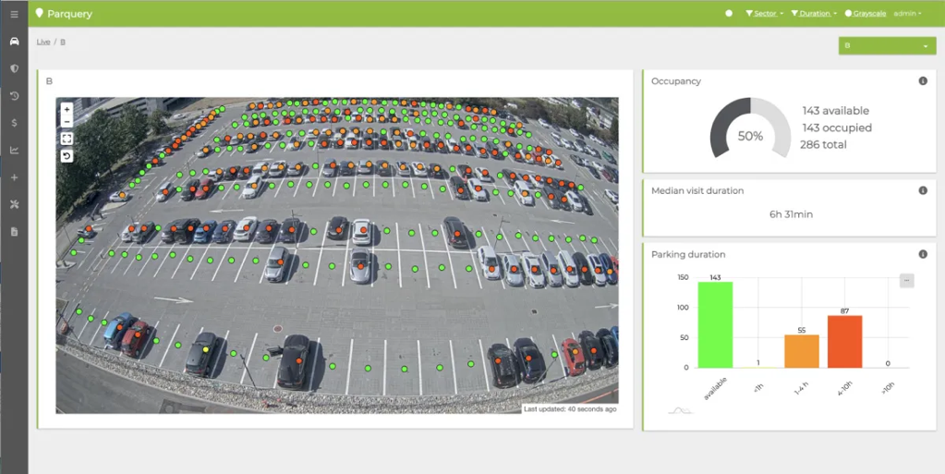
Figure 2

How ours will be different: One way my smart lot will be different will be by using weight sensors as opposed to motion censored detectors. We will provide designated convenient spaces for expecting mothers, families with young children, seniors, and people with physical impairments first and up front. My weight sensors will be solar-powered, generating clean electricity and ultimately does not add air pollution to our already deteriorating planet. Our app will be able to tell guests how busy and full the lot is at any time during open hours, let you pre-pay for your spot if needed (the closer the spot, the pricier), GPS navigation straight to your desired available spot, and a safety feature that contacts the lot security within seconds for assistance or emergencies.

Visions and Scope: My company LotLink decided to take on this project in hopes of ending parking lot traffic, reduce tardiness due to being unable to find a parking space, and all around, reduce stress for everyone. I started LotLink because I got tired of seeing those green overhead lights on on busy shopping days, only to soon realize the spot was actually taken, and the sensor simply wasn’t working. My company prides itself on accuracy and we prioritize being as sustainable as possible.

Week 2:
WBS (Work Breakdown Structure) for our parking app:

Timeline (estimate) and Gantt Chart:

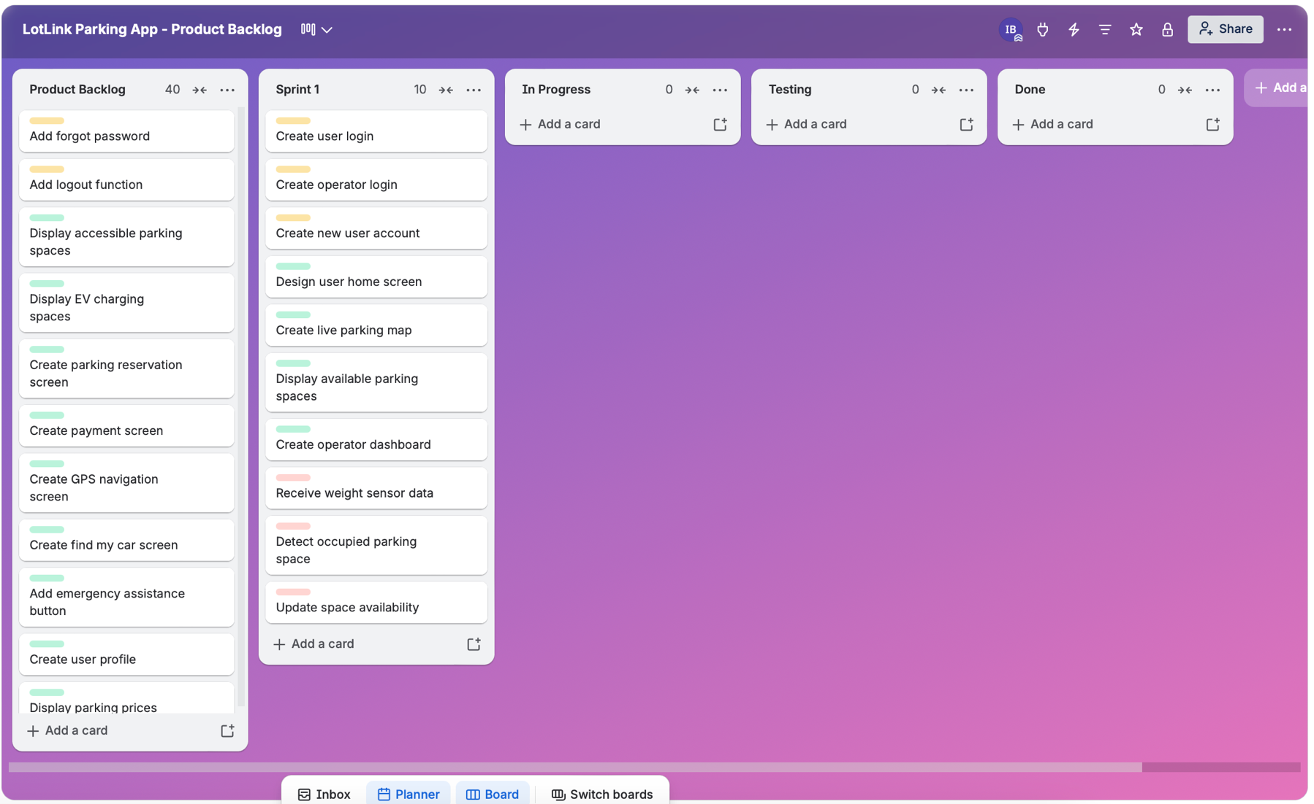
Week 3 Parking App backlog:

Week 4 Risk Register:

Communication Plan:

Project Team Meeting All Teams - Weekly Teams/Zoom Review overall progress
Development Meeting App & IT Team Twice Weekly Teams Discuss App & Sprint progress
Engineering Meeting Sensor/Hardware Team Weekly In-Person/Teams Review all sensors, installations, & hardware issues
Project Manager Meeting Leads & PM Weekly Teams Discuss schedule, budget, updates, & risks
Stakeholder Meeting Stakeholders & PM Weekly Email Report accomplishments, risks, and future steps

The goal of LotLink's communication strategy is to inform stakeholders and project teams at every stage of development. Tasks and Sprint progress will be tracked using Trello, and team members will be able to discuss schedule modifications, potential hazards, and forthcoming duties at weekly meetings. Weekly progress reports outlining finished work, ongoing issues, and the project's next actions will be sent to stakeholders. Instead of waiting for a scheduled meeting, urgent technical or safety issues will be communicated right away.

